CLOUD COMPUTING INTERNSHIP REPORT

Deploying a Static Portfolio Website Using Amazon S3
A Report Submitted in Fulfilment of the Cloud Computing Internship Requirements

Submitted by: | Muhammad Masab
Internship Track: | Cloud Computing
Cloud Provider: | Amazon Web Services (AWS)
Core Service Used: | Amazon Simple Storage Service (S3)
AWS Region: | Asia Pacific (Mumbai) — ap-south-1
S3 Bucket Name: | portfolio-website-hosting2026
Project Title: | Deploying a Static Portfolio Website Using Amazon S3
Report Date: | July 2026

Table of Contents

1. Introduction
Amazon Web Services (AWS) is one of the world's leading cloud computing platforms, offering a broad range of on-demand infrastructure and application services. As part of the Cloud Computing internship, a hands-on project was undertaken to design and deploy a static portfolio website using Amazon Simple Storage Service (Amazon S3). Amazon S3 is an object storage service that, in addition to storing files, can be configured to serve static web content directly over HTTP, making it a cost-effective and scalable solution for hosting personal and small business websites without the need to provision or manage a dedicated web server.
This report documents the complete workflow followed to deploy the portfolio website: creating and configuring an S3 bucket, uploading the website's static assets (HTML, CSS, and JavaScript files), enabling the static website hosting feature, configuring public access permissions, attaching a bucket policy, and finally testing the live website endpoint. A troubleshooting issue encountered during deployment is also documented, along with the corrective action taken to resolve it.

2. Objectives
The primary objectives of this project were as follows:
- To gain practical, hands-on experience with Amazon S3 as a cloud storage and static web hosting service.
- To create and configure an S3 bucket suitable for hosting a static website.
- To upload and organise static website files (HTML, CSS, and JavaScript) within the bucket.
- To enable and configure the S3 Static Website Hosting feature.
- To understand and correctly configure S3 Block Public Access settings and bucket policies to allow public, read-only access to website content.
- To deploy the website and verify that it is publicly accessible via the S3 website endpoint.
- To identify, diagnose, and resolve a real deployment error encountered during the process.

3. Technologies Used
The following tools and technologies were used to complete this project:
- Amazon Web Services (AWS) Management Console — used to create and configure all cloud resources.
- Amazon S3 (Simple Storage Service) — used as the primary storage and static website hosting service.
- AWS Region: Asia Pacific (Mumbai) — ap-south-1, selected to minimise latency for the target audience.
- HTML5, CSS3, and JavaScript — used to build the front-end of the portfolio website (index.html, style.css, script.js).
- S3 Bucket Policy (JSON/IAM policy language) — used to grant public read access to website objects.
- Web browser — used to test and verify the deployed website endpoint.

4. Step-by-Step Implementation

4.1 Create the S3 Bucket
The first step was to create a dedicated S3 bucket to hold the website files. A globally unique bucket name, portfolio-website-hosting2026, was chosen, and the bucket was created in the Asia Pacific (Mumbai) region (ap-south-1). Upon creation, the AWS Console displayed a confirmation banner and the new, empty bucket was ready to receive objects, as shown in Figure 1.
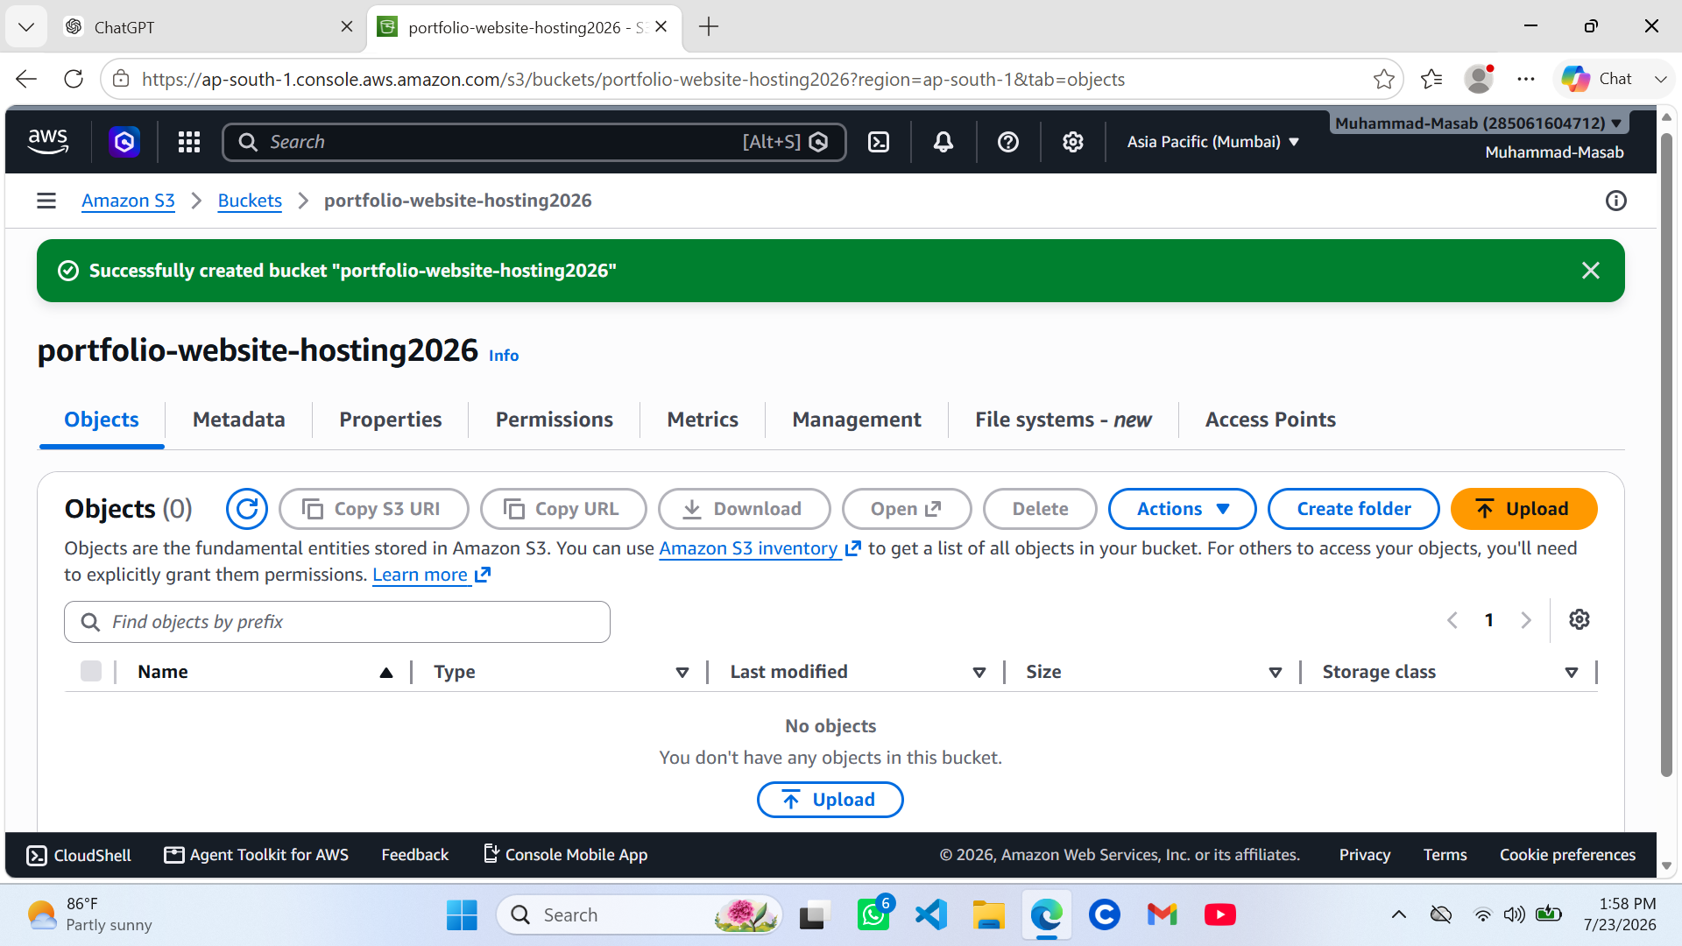
Figure 1: S3 bucket "portfolio-website-hosting2026" successfully created in the Asia Pacific (Mumbai) region, with no objects uploaded yet.

4.2 Upload Website Files
The static website files — index.html, style.css, and script.js — were then added to the upload queue in the S3 console. Figure 2 shows the upload screen prior to submission, listing all three files (74.3 KB total) together with their detected MIME types (text/html, text/css, and text/javascript).
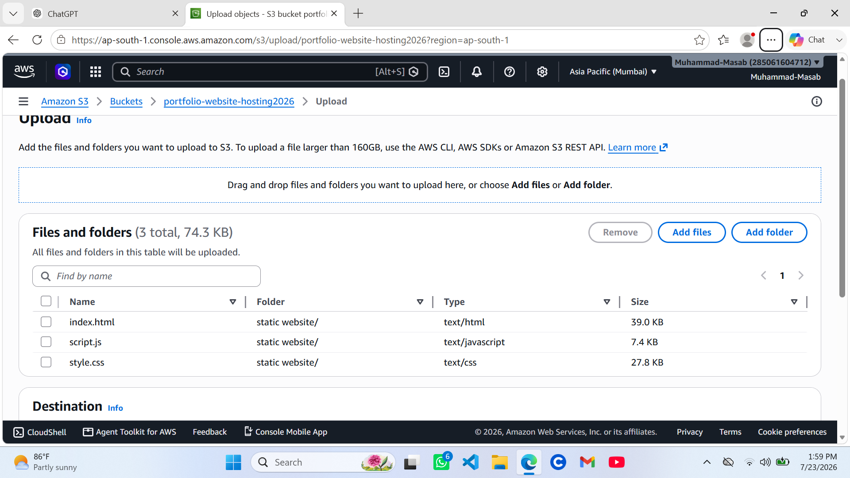
Figure 2: Website files (index.html, script.js, style.css) staged for upload to the S3 bucket.
After the upload was submitted, the AWS Console confirmed that all three files had been uploaded successfully, with each object reporting a "Succeeded" status and no errors, as shown in Figure 3.
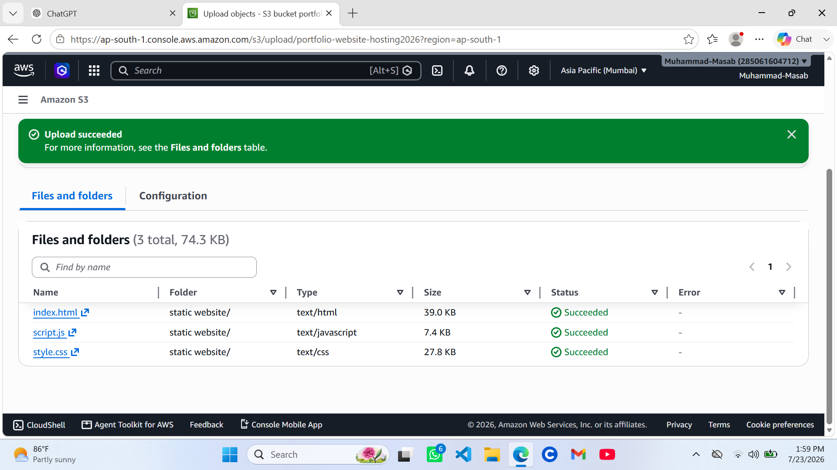
Figure 3: Upload confirmation showing index.html, script.js, and style.css uploaded successfully to the bucket.

4.3 Enable Static Website Hosting
With the files uploaded, the bucket's Properties tab was used to edit the Static website hosting configuration. Hosting was set to Enable, and the hosting type was set to "Host a static website", using the bucket endpoint as the site's web address, as shown in Figure 4. The index document field was set to index.html so that S3 would serve this file as the website's home page.
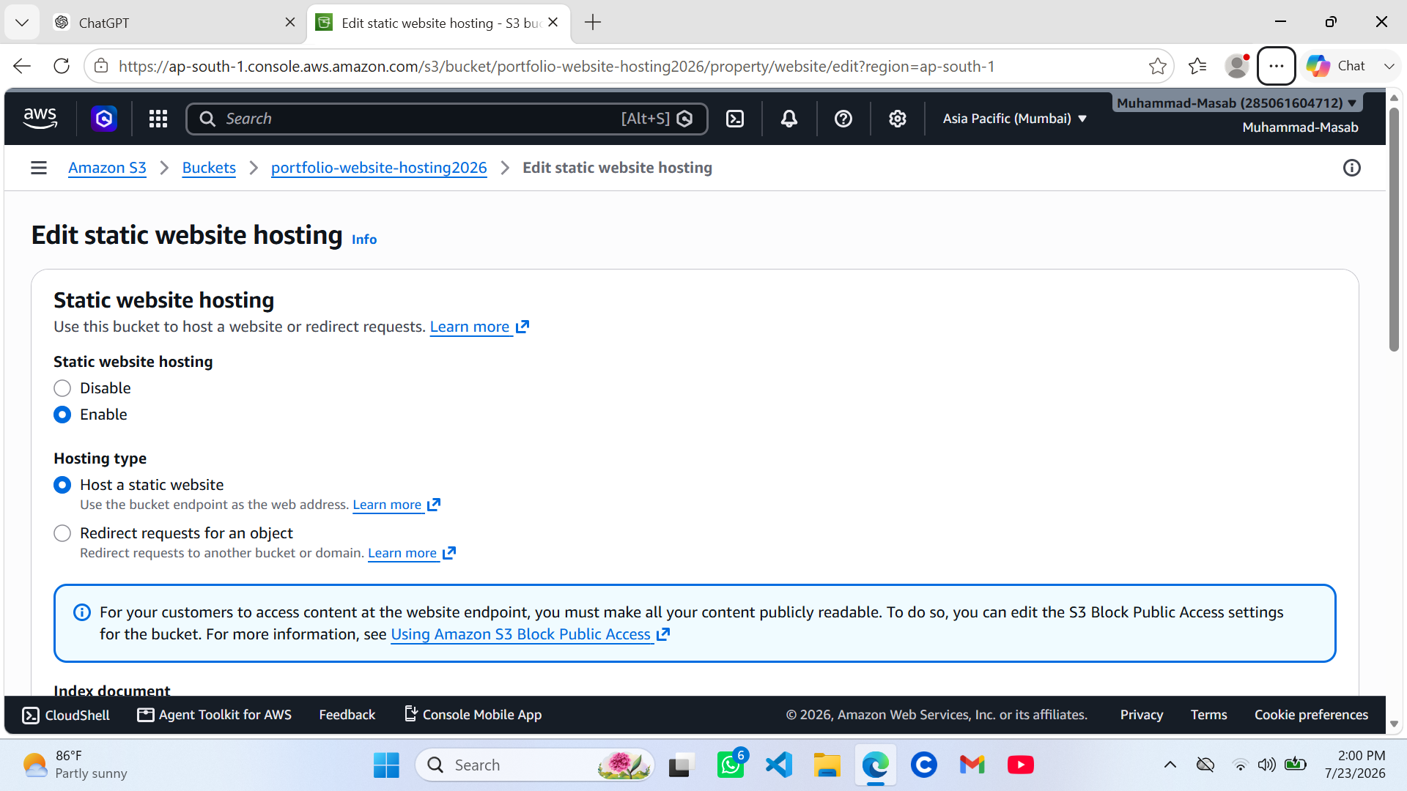
Figure 4: Static website hosting enabled for the bucket, configured to host a static website with the bucket endpoint as the web address.

4.4 Configure Public Access
By default, S3 buckets block all public access as a security safeguard. Since a publicly accessible website requires visitors to read objects without authentication, the bucket's Block Public Access (bucket settings) were edited. All four block-public-access checkboxes — covering public access granted through new and existing ACLs, and through new and existing bucket or access point policies — were unchecked, as shown in Figure 5, so that a subsequent bucket policy could grant public read access.
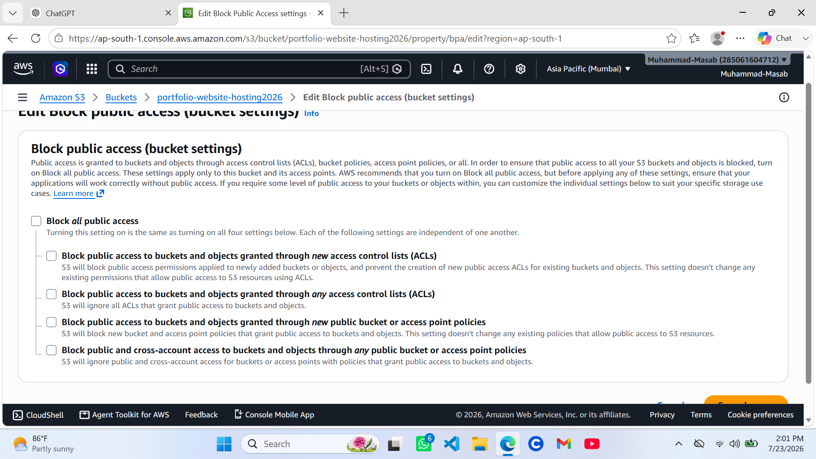
Figure 5: Block Public Access (bucket settings) edited to permit public access, a prerequisite for serving website content to visitors.

4.5 Add Bucket Policy
Disabling Block Public Access alone does not make objects public; it only permits public-access policies to take effect. A bucket policy was therefore attached to explicitly grant read-only (s3:GetObject) permission to everyone (Principal: "*") for all objects in the bucket. The policy used is presented and explained in Section 6.

4.6 Deploy and Test the Website
Once hosting was enabled and public read access was granted, the website was tested by opening the S3 static website endpoint (in the form http://portfolio-website-hosting2026.s3-website.ap-south-1.amazonaws.com) in a web browser. This step also surfaced the deployment issue documented in Section 7, which was resolved by correcting the object structure inside the bucket. After the fix, the portfolio homepage loaded correctly, confirming a successful deployment (Section 8).

5. Bucket Policy and Explanation
The following bucket policy was applied to grant public read-only access to all objects stored in the portfolio-website-hosting2026 bucket:
{
"Version": "2012-10-17",
"Statement": [
{
"Sid": "PublicReadGetObject",
"Effect": "Allow",
"Principal": "*",
"Action": "s3:GetObject",
"Resource": "arn:aws:s3:::portfolio-website-hosting2026/*"
}
]
}
Explanation:
- Version: Specifies the AWS IAM policy language version used to interpret the policy.
- Sid (Statement ID): PublicReadGetObject is a descriptive label identifying the purpose of the statement.
- Effect: "Allow" permits the action described, rather than denying it.
- Principal: "*" indicates that the permission applies to any user or requester, which is required for a public-facing website.
- Action: s3:GetObject grants permission only to read (download/view) objects — it does not permit writing, deleting, or listing the bucket, keeping the permission scope minimal.
- Resource: arn:aws:s3:::portfolio-website-hosting2026/* applies the permission to every object inside the bucket, which is necessary so that the browser can retrieve index.html, style.css, and script.js.
Together with the Block Public Access settings configured in Section 4.4, this policy ensures that only anonymous, read-only requests are permitted, while all other operations on the bucket remain restricted to authenticated, authorised users.

6. Error and Troubleshooting
When the website endpoint was first accessed after enabling static website hosting, the browser returned a "404 NoSuchKey" error indicating that index.html could not be found.
<Error>
<Code>NoSuchKey</Code>
<Message>The specified key does not exist.</Message>
<Key>index.html</Key>
</Error>
Root Cause:
S3 static website hosting serves the index document from the root of the bucket. During the upload step (Section 4.2), the files were uploaded inside a subfolder named "static website/" rather than directly at the bucket root. As a result, the object key for the home page was static website/index.html instead of index.html, which is the key S3 looked for when serving the site's root URL.
Resolution:
The issue was resolved by moving index.html, style.css, and script.js out of the "static website/" folder and into the root of the bucket, so that their object keys matched exactly what the static website hosting configuration expected (index.html at the root). After relocating the files, the website endpoint was reloaded and the portfolio homepage rendered correctly, confirming that the error had been resolved.
Key Lesson:
When configuring S3 static website hosting, the index document (and any other root-level assets it references) must reside directly at the bucket root, not inside a nested folder, unless the hosting configuration and all internal file references are explicitly adjusted to account for that folder path.

7. Deployment Result
After correcting the object structure, the portfolio website was successfully deployed and made accessible through the S3 static website endpoint associated with the bucket portfolio-website-hosting2026 in the Asia Pacific (Mumbai) region. Visitors are able to load the homepage (index.html), with the associated stylesheet (style.css) and script (script.js) loading correctly, confirming that the site's assets were being served with the appropriate content types by Amazon S3.
The deployment demonstrates a fully functional, serverless static website hosting pipeline built entirely on Amazon S3, without the need for a traditional web server, operating system patching, or infrastructure management.

8. Security Considerations
- Least-privilege access: The bucket policy grants only s3:GetObject (read-only) permission, so public users can view website files but cannot upload, modify, or delete them.
- Scoped Block Public Access: Public access was enabled only for this specific bucket rather than at the account level, limiting the change in exposure to the intended website bucket only.
- No sensitive data in the bucket: Only static, non-confidential front-end assets (HTML, CSS, and JavaScript) intended for public viewing were stored in the bucket.
- HTTPS via CDN (recommended future improvement): The native S3 website endpoint serves content over HTTP only; fronting the bucket with Amazon CloudFront would add HTTPS encryption, a custom domain, and edge caching.
- Access monitoring (recommended future improvement): Enabling S3 server access logging or AWS CloudTrail would provide visibility into requests made to the bucket.

9. Cost Considerations
Amazon S3 static website hosting is a highly cost-effective option for small, low-traffic websites such as a personal portfolio, since there is no dedicated server to provision or pay for continuously. Costs are incurred only for the resources actually consumed:
- Storage cost: Charged per GB-month for the objects stored in the bucket. The website used in this project totals approximately 74.3 KB, resulting in a negligible storage cost.
- Request cost: Charged per GET/PUT/LIST request made to the bucket; each page load generates a small number of GET requests.
- Data transfer cost: Charged for data transferred out of S3 to the internet when visitors load the website; for a low-traffic portfolio site this remains minimal and, depending on usage, may fall within the AWS Free Tier.
- No compute or server costs: Because S3 handles the hosting directly, there are no charges for EC2 instances, load balancers, or operating system licensing.
Overall, for a low-traffic static portfolio site, the total monthly cost is typically a fraction of a US dollar, making Amazon S3 a highly economical hosting solution compared to traditional server-based hosting.

10. Learning Outcomes
- Developed practical skills in creating and configuring Amazon S3 buckets through the AWS Management Console.
- Learned how to upload and organise static web assets within an S3 bucket.
- Gained a working understanding of the S3 Static Website Hosting feature and its reliance on a correctly specified index document at the bucket root.
- Understood the relationship between S3 Block Public Access settings and bucket policies in controlling public accessibility.
- Learned to read, write, and interpret an IAM/S3 bucket policy in JSON format, including principals, actions, effects, and resource ARNs.
- Developed troubleshooting skills by diagnosing a real "404 NoSuchKey" deployment error and tracing it back to an incorrect object key path caused by an unintended subfolder.
- Gained an appreciation for the cost-effectiveness and scalability of serverless static website hosting compared to traditional server-based approaches.

11. Conclusion
This project provided practical, end-to-end experience in deploying a static website using Amazon S3, covering bucket creation, file upload, static website hosting configuration, public access management, bucket policy design, and deployment verification. The "404 NoSuchKey" error encountered during initial testing, caused by the website files residing inside a "static website/" subfolder rather than the bucket root, was successfully diagnosed and resolved, reinforcing the importance of the object key structure in S3 static website hosting.
The completed project, portfolio-website-hosting2026, demonstrates that Amazon S3 is a reliable, scalable, and low-cost platform for hosting static websites, and the exercise strengthened both the technical and problem-solving skills expected of a Cloud Computing intern working with AWS.

